Simplicity

The theme Simplicity allows different interpretations, enabling artists to play with the concept. A simple situation, a basic object, an uncomplicated feeling, or something complicated explained simply ...
Each artist represented Simplicity their were way, in their current circumstances. The result was a light show, where nature and its elements integrated into the artwork. In some, elements created by the culture chosen to address the issue. Some artists expressed simplicity through geometric shapes. Others preferred to use abstract shapes to communicate their feelings.

Different materials and techniques were used. In some works, soft colors relax our eyes. In others, intense colors attract our attention. Through creativity and perspective of each artist, the exhibition makes us reflect on what is simple. Simplicity "speaks" explicitly of love in at least two works, and implicitly, in all of them ... leaving us speechless.

We hope that while admiring each detail in the art works presented here, you connect more and more with yourself, and quietly, you think about the complicated world we live in and the importance that simplicity has in our lives.
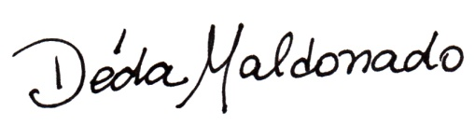
Fiber artist, curator, Studio Art Quilt Associates for Mexico, South America, Central America and the Caribbean.
deda@dedamaldonado.com

NOTE: Simplicity Exhibit has 23 art quilts, they are all the same size 120cm x 50cm (48” x 19”) and have the same insurance value $500.00 each.
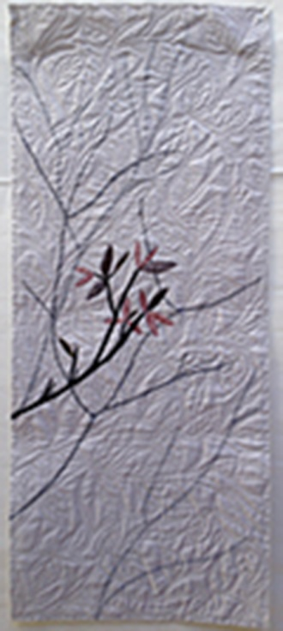  Bruma Oriental | 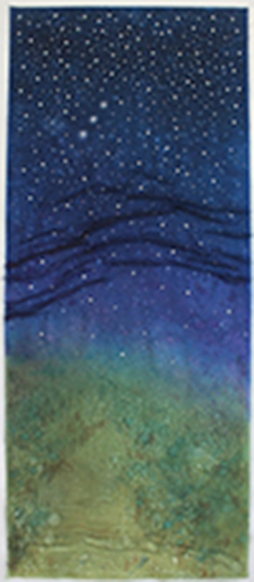  Noite Estrelada |  | 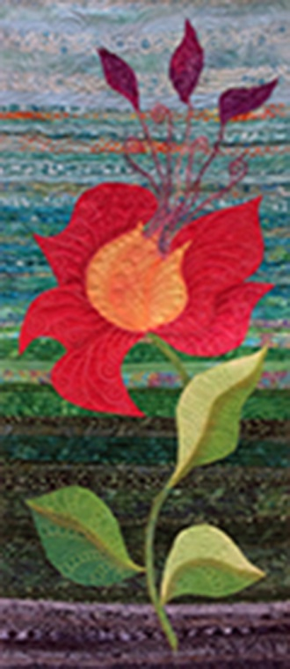  Agora |  | 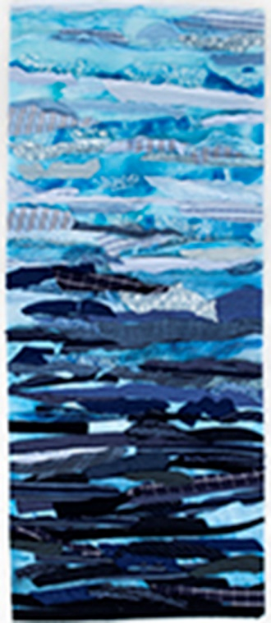Tudo Pode Ser Simples
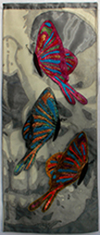  Mortevida | 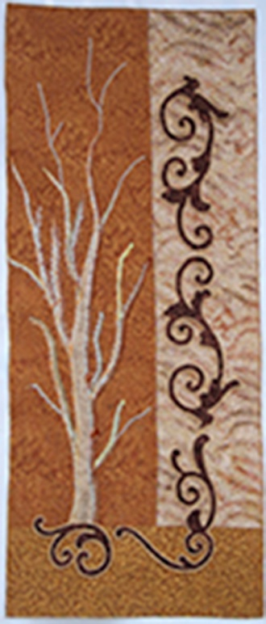  Natureza Adormecida |  | 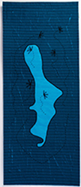  Tudo É Todos |  | 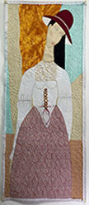  Aurora
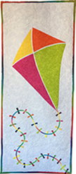  Pipa | 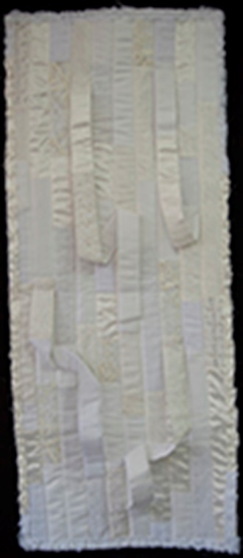  Nem Tão Simples Assim! |  | 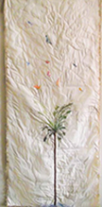  Voo no Cerrado |  | Um Dia
A Areia, O Mar,  e Eu | 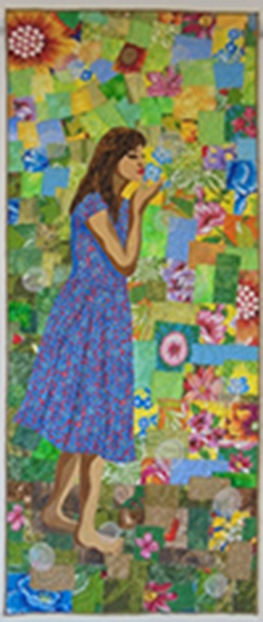  O Encanto da Chita |  | 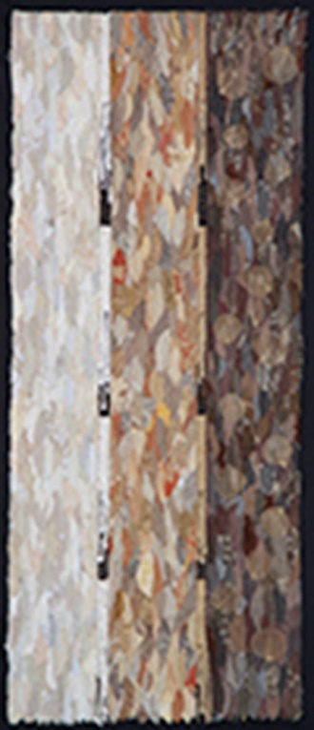  Tramas da Vida |  | 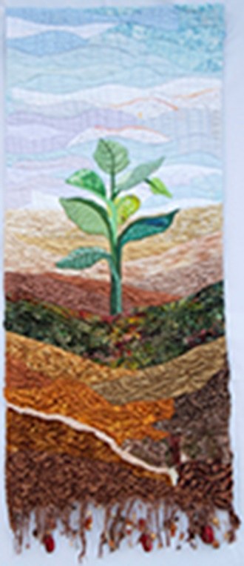  Depois da Chuva
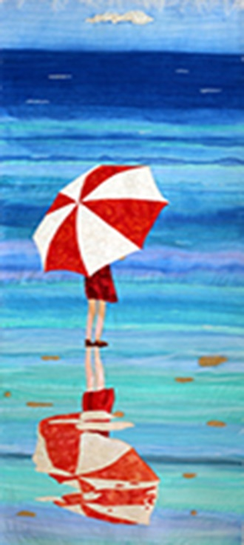  Caminhada na Praia | 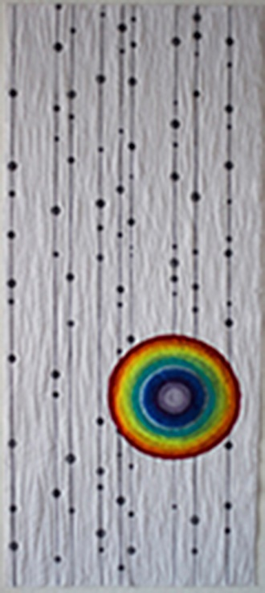  Simples Contrastes |  | 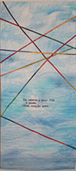  Total Arcoiris |  | 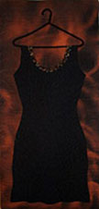  Pretinho Basico
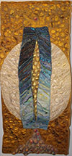  Vida |  | 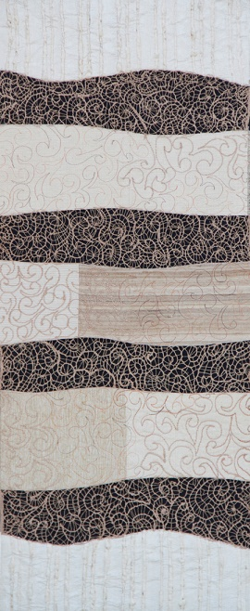  Simplicidade do Fio |  | 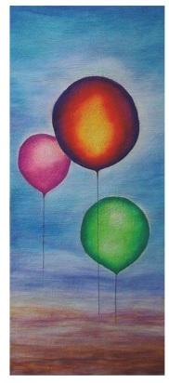  Adeus

